 **COMMUNITY ACADEMY Application**



# Please Read Carefully Before Proceeding

**Please type or print legibly**. All applications that are incomplete and/or unsigned will not be accepted. There is no charge for admission into the Richmond Police Department’s Citizens Academy. Completed applications should be mailed or emailed to:

Richmond Police Department

CYIS Division, Room 421

**Attn: Community Academy Program Facilitator**

200 West Grace Street

Richmond, VA 23220

Email: Jasmine.Perez@rva.gov

Phone: (804) 646-5158

Date: Date of Birth:

# Personal Information

|  |
| --- |
| Full Name:  Full Home Address:  Sex: Race:    Mobile Number: _______  Home Number:  Office Number:_____________________________________________________  E-mail Address:      Are you currently enrolled in college/university?  Yes  No  *If yes, please list name of college/university*: _______ P*lease list name of college/university academic major/minor:*      Do You Have Any Impairment(s) (*Include Pregnancy*)?  Yes  No  *If yes, please list*:  ________________________________________________________________ |

|  |
| --- |
| Emergency Contact Name #1:  Emergency Contact Phone Number:    Emergency Contact Name #2:  Emergency Contact Phone Number: |

# Background

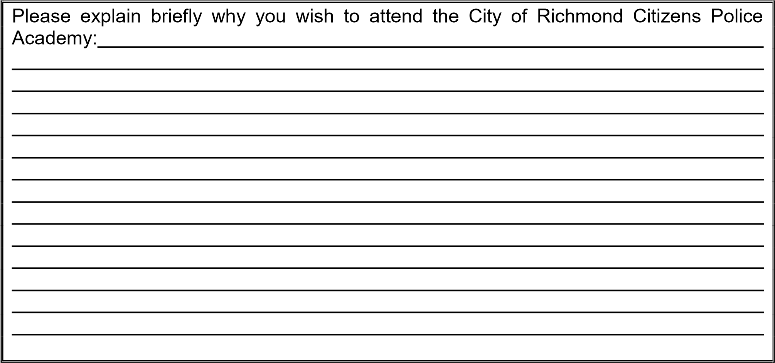

|  |
| --- |
| Please list any associations, clubs, or organizations you are affiliated with: |

**Please review your answers carefully and read the statement below before signing this application.**

I hereby certify that there are no willful misrepresentations, omissions or falsifications in the foregoing statements and answers to questions. I understand that any misrepresentations, omissions or false statements on this application shall be sufficient cause for rejection for enrollment or dismissal from the City of Richmond Police Department’s Community Academy. **Physically sign your name on this form. OR you may type your name on this form. *Please be advised typing your name on this form indicates you have consented to have it be accepted as your signature.\***

If you are interested in conducting a **Police Ride Along** OR **Volunteer in Police Services** within the Community Care Unit (CCU), please go to the Richmond Police Department’s Websites listed below and fill out an application:

[**https://www.rva.gov/police/ride-along-program**](https://www.rva.gov/police/ride-along-program)

[**https://www.rva.gov/sites/default/files/2019-01/VolunteersInPoliceServices.pdf**](https://www.rva.gov/sites/default/files/2019-01/VolunteersInPoliceServices.pdf)

**Email all applications to the CCU Program Facilitator:** Jasmine.Perez@rva.gov

**Applicant’s Signature**  **Date**

